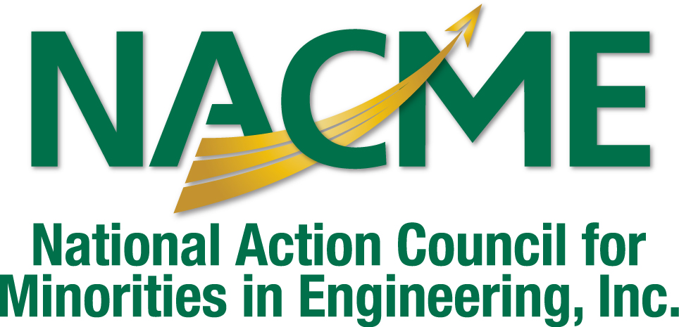

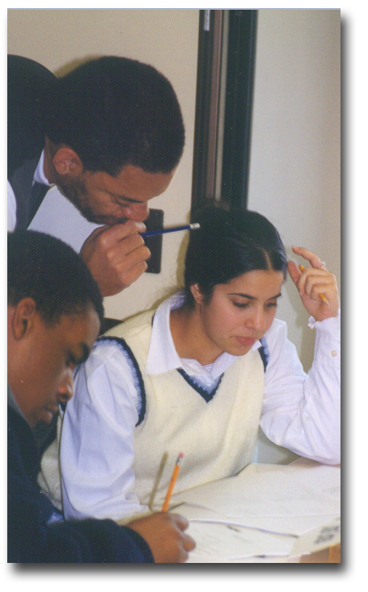

NACME’s mission is to provide leadership and support for the national effort to increase the representation of successful African American, American Indian and Latino women and men in engineering and technology,
math and science-based careers.

National Action Council for
Minorities in Engineering, Inc.
440 Hamilton Avenue, Suite 302
White Plains, NY 10601-1813
www.nacme.org
www.nacmebacksme.org

